
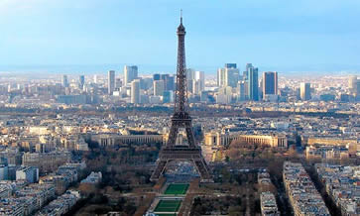
Contact:
Jeanne Hughston
864-993-1955 jhug@nctv.com

Category 3, Brittany deck $3591

Category 2, Brittany deck $3991

Category 1, Normandy deck with French Balcony $4391

Call for available discounts!
Rates are per person.
Airfare and insurance are available at additional cost.

Deposit of $300 per person due May 21, 2012.
Deposit is non refundable.
Final payment due January 3, 2013.

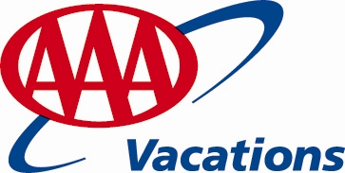

Day Port/City
Day 1 Paris
Day 2 Paris
Day 3 Paris, transfer to ship (embark)
Day 4 Les Andelys
Day 5 Rouen (Normandy Beaches)
Day 6 Rouen
Day 7 Caudebec-en-Caux (Honfleur)
Day 8 Vernon (Giverny)
Day 9 Paris
Day 10 Paris (disembark), transfer to the airport
Begin your visit with a two-night stay at a deluxe Parisian hotel which will be your base of operations from which to explore the delights of Paris—such as an included panoramic tour of the “City of Light.”
Sail all the way to Caudebec-en-Caux though the scenic, inspirational countryside of northern France.
Visit the charming French village of Les Andelys, the city of Rouen, and the harbor town of Honfleur, all of which were lovingly depicted by the Impressionists. Walk the beaches of Normandy where Allied forces landed during WWII’s D-Day Invasion, and see the site where Joan of Arc was martyred. Experience Monet’s home in his beloved village of Giverny, where you will see the familiar Japanese bridge and water lily-covered pond that inspired his great works of art. Spend time in one of the world’s grandest cities, Paris, the “City of Light”—with its iconic Eiffel Tower, famed Champs- Élysées, and grand Notre Dame Cathedral.
Piedmont Technical College
Paris & Normandy

Paris to Paris | 10 Days

April 4, 2013 – departure date from USA, return April 14, 2013
Combine a passion for the good life with art, culture, and brilliant landscapes, and you have northern France.

Paris & Normandy Includes:
- 7-night cruise in a riverview stateroom on the alluring River Baroness
- 2 nights in Paris at the superior first-class Radisson Blu Ambassador hotel*
- All meals onboard, prepared using the finest and freshest ingredients
- 9 breakfasts, 5 lunches, 7 dinners
- Captain’s Welcome Gala and Farewell Dinners
- Complimentary fine wines, choice of beer, and soft drinks during lunch and dinner onboard; replenished bottled water daily in your stateroom; and 24-hour specialty coffee and tea bar
- 10 excursions, including 3 “Choice Is Yours” options, fully hosted by English-speaking local guides
- An experienced Cruise Manager and attentive, all English-speaking staff
- State-of-the-art Quietvox portable audio headset system on all shore excursions
- Use of bicycles and Nordic walking sticks throughout your cruise
- Captivating onboard local entertainment
- Signature Lecture: “The Seine River in Impressionist Paintings”
- Exclusive Multigenerational Family-Friendly Program during summer months
- All transfers on arrival and departure days
*Hotel is subject to change

*Rate is per person and listed in US dollars. Price includes standard accommodations based on double occupancy. Additional fees apply for category upgrades. Subject to availability. Capacity controlled. Other restrictions may apply. Uniworld reserves the right to withdraw or change offers at any time. For complete details on all promotions, general information, and terms and conditions applicable to all Uniworld trips, please visit uniworld.com. CST #2075415-20

